# **Making predicted lesion masks**

## Assumptions:

* You are signed into Pikelab
  + Used to get matrix files, T1 masks, T1 lesion masks
* Mac box
* Installed MATLAB
  + 2018a
* Have dicm2nii toolbox for MATLAB
  + <https://github.com/xiangruili/dicm2nii>
  + Use the nii_tool for saving/loading nifti files
* Have xml2struct tool for MATLAB
  + <https://github.com/kndiaye/matlab/blob/master/xml2struct.m>
  + Use to get xml2struct command
* FSL
  + FSL 5.0.11
  + FLIRT v6.0
* Assumes that all function files and patient files are in same folder.

## Functions:

* extractNiftiZipInput2(cmd, cmd2, zipfile, outfile, RigidTransformFile)
  + MATLAB function
  + Takes zip files and turns binary .raw files into three nifti images
    - Magnitude, Temperature, and Thermal Dose
* Volume3.command(patient 1, patient x)
  + BASH command
  + Processes the output from extractNiftiZipInput2 and produces predicted lesion masks and files for DSC analysis
  + Made to work on single patient or multiple patients
* genReport(patient 1, patient x)
  + BASH command
  + Takes the predicted lesion masks and DSC files and turns into .csv report

## How to process patients, including report generation

1. Open up MATLAB
2. Run extractNiftiZipInput2 for desired patient – See instructions below
3. Open up a terminal
4. Go the directory containing the functions
5. Run predictLesions.command for desired patients – See instructions below
6. Run genReport.command for desired patients – See instructions below

## extractNiftiZipInput2(cmd, cmd2, zipfile, RigidTransformFile, outFile)

* Purpose
  + Produces the magnitude, temperature, and thermal dose maps for a patient
* Requires
  + Access to Pikelab
  + MATLAB 2018a
* Input – Input is set-up to autocomplete using the included functionSignatures.json file
  + Cmd – Tells MATLAB if you want temperature maps, magnitude maps, or both
    - Use ‘tempMap’,’magMap’, or ‘all’ respectively
  + Cmd2 – Tells MATLAB if you want thermal dose maps, only temperature maps, or both
    - Use ‘thermalDose’,’ tempMap’, or ‘all’
  + Zipfile – The patient file you want to process
    - Input as a filepath leading to zip file
  + RigidTransformFile – The matrix that converts files from intra-operative space to pre-operative space
    - Requires Pikelab
    - Generally taken from /Volumes/Pikelab/SPichardo
    - Can be saved locally
  + Outfile – The destination file where patient nifti files are to be saved
    - Input as a filepath
    - Optional input, not recommended to use, will make processing and analysis difficult
* Outputs
  + Magnitude Maps – Default Names:
    - IntraOp-Magnitude#-Sonication_#.nii.gz
    - PreOp-Magnitude#-Sonication_#.nii.gz
  + Temperature Maps – Default Names:
    - IntraOp-Thermal#-Sonication_#.nii.gz
    - PreOp-Thermal#-Sonication_#.nii.gz
  + Thermal Dose Maps – Default Names:
    - IntraOp-CEM240-#-Sonication_#.nii.gz
    - PreOp-CEM240-#-Sonication_#.nii.gz
* Examples – Use within MATLAB
  + Extract: temperature maps, magnitude, maps, thermal dose maps
    - extractNiftiZipInput2(‘all’,’all’,’~/Desktop/9002-May19 2017.zip’,’Volumes/Pikelab/SPichardo/9002-Intra-to-Pre.RAS’)
  + Extract temperature maps and thermal dose maps
    - extractNiftiZipInput2(‘thermal’,’all’,’~/Desktop/9002-May19 2017.zip’, ’Volumes/Pikelab/SPichardo/9002-Intra-to-Pre.RAS’)
  + Extract temperature maps only
    - extractNiftiZipInput2(‘thermal’,’temperature’,’~/Desktop/9002-May19 2017.zip’, ’Volumes/Pikelab/SPichardo/9002-Intra-to-Pre.RAS’)
  + Extract all maps and save to other directory
    - extractNiftiZipInput2(‘all’,’all’,’/Volumes/Pikelab/SPichardo/9002-May19 2017.zip’,’/Volumes/Pikelab/SPicarod/9002-Intra-to-Pre.RAS’,’~/Desktop/9002’)

## predictLesions (patient 1, patient x)

* Purpose:
  + Produced the predicted lesion maps using the thermal dose maps. Operates with two cases.
    - Case 1: Single patient. Input patient number
    - Case 2: Range of patients.
      * Will process patients from lowest number to highest, incrementally
  + Produces the Dice coefficient denominator and numerator niftis for genReport.
* Requires
  + The thermal dose map outputs from MATLAB
  + FSL 5.0.11
  + FLIRT v6.0
* Input
  + Patient 1 – Lowest number patient or only patient wanting processing
    - Function will throw an error if not provided
  + Patient x (optional) – Highest number patient
* Outputs
  + Predicted lesion masks
    - Predicted-Lesion-Mask-###.nii.gz
  + DSC numerator and denominator files
    - DSC_Denom_###.nii.gz
    - DSC_Num_###.nii.gz
  + ### is the thermal dose threshold
* Examples
  + makeLesions user$ ./Volume3.command 9002
    - Will process patient 9002 only
  + makeLesions user$ ./Volume3.command 9004 9006
    - Will process patients 9004, 9005, and 9006
* Possible Thrown Errors:
  + Too many inputs
  + No input
  + The thermal dose maps are not available

## genReport (patient 1, patient x)

* Purpose:
  + Generates a report for volume and dice co-efficients for the patients required works for three cases:
    - Case 1: Generate a report from patients 9002 to 9021. Enter no arguments
    - Case 2: Generate a report for a single patient. Enter single argument
    - Case 3: Generate a report for a specific range of patients. Enter argument 1 then argument 2
* Requires:
  + FSL 5.0.11
* Assumptions
  + That the file tree structure is followed
* Input
  + Patient 1 – Optional – First or only patient that is needed
  + Patient x – Optional – Final patient wanted processing
* Output
  + TotalReport.csv in analysis directory
* Examples
  + Case 1
    - makeLesions user$./genReport.command
  + Case 2
    - makeLesions user$ ./genReport.command 9010
  + Case 3
    - makeLesions user$ ./genReport.command 9003 9002
* Possible Thrown Errors
  + Too many inputs

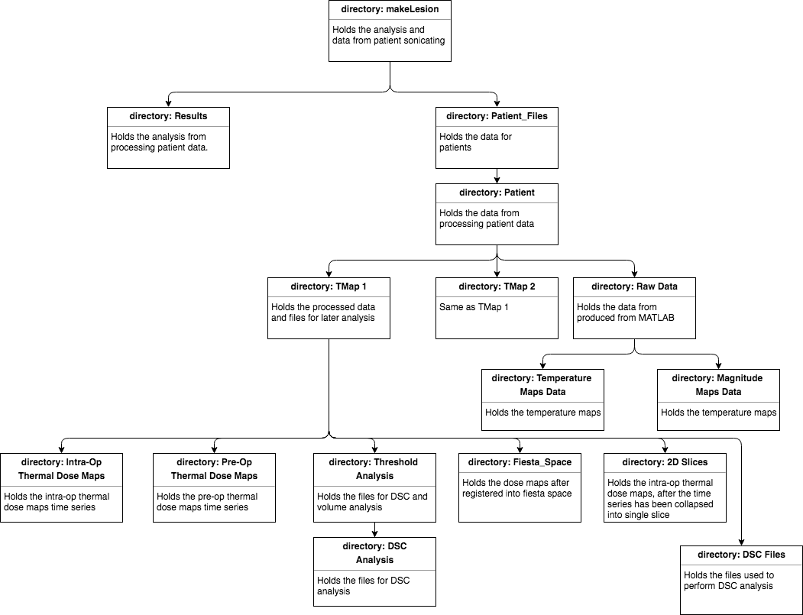

## Updates:

* V2
  + Modified extractNiftiZipInput
    - Swap position of RigidTransformFile and outFile
    - outFile now has default set to maintain file tree
    - outFile is now optional
    - Removed code line that moved files that didn’t need to exist
  + Modified predictLesions
    - Merged sub functions getSagittal and getFiles into getFiles
      * Now all files are placed into their folders in one function
    - Merged the DSC and Volume subfunctions
      * DSC files are made within the volume function
      * Easier to redefine threshold limits